Boston 311 Service Requests:
A Neighborhood-Level Analysis of Government Responsiveness and Equity (2015-2019)
Module 2 — Final Project: Initial Analysis Report
ALY 6015: Intermediate Analytics
Dr. Roy Wada
July 20, 2026
Prepared by:
Yingkai Ren
Joseph Tarlin

Project Title
Boston 311 Service Requests: A Neighborhood-Level Analysis of Government Responsiveness and Equity (2015-2019). This project examines whether the City of Boston's 311 non-emergency service request system responds to constituent complaints equally across neighborhoods, or whether response speed is systematically related to a neighborhood's income, poverty rate, and racial composition.

Group Members
- Yingkai Ren
- Joseph Tarlin

Dataset Description
The primary dataset is Boston's 311 Service Requests data, obtained from the City of Boston's open data portal (Analyze Boston). Five annual files (2015-2019) were downloaded and combined using dplyr::bind_rows(), producing a single longitudinal dataset of 1,199,657 service requests. Each record represents one constituent-submitted case and includes the case open and close timestamps, the responsible city department, the submission channel, the case's on-time/overdue status relative to the City's own service-level target, and the neighborhood in which the request originated.
This 311 dataset was supplemented with a neighborhood-level demographic profile compiled by the Boston Planning & Development Agency (BPDA) from the 2015-2019 American Community Survey (5-year estimates). This workbook reports population, median age, racial/ethnic composition, median household income, per-capita income, and poverty rate for each of Boston's 22 official planning neighborhoods. Because the 311 dataset's neighborhood field uses some informal or combined labels (e.g., "Allston / Brighton," "South Boston / South Boston Waterfront") that do not correspond one-to-one with the Census neighborhoods, a crosswalk was built and combined labels were assigned a population-weighted average of their component neighborhoods' Census characteristics. Records with no identifiable neighborhood match (a generic "Boston" citywide code, blank entries, or "Chestnut Hill," which BPDA does not tabulate separately) were excluded from the neighborhood-linked analysis. This is a horizontal (attribute) merge of a supplemental dataset, distinct from the vertical row-binding used to combine the five years of 311 data.

Research Questions / Problem Statement
This project treats 311 response performance as a proxy for municipal government accountability. The guiding question is whether the City of Boston resolves service requests with the same speed and diligence regardless of where a constituent lives, or whether neighborhoods with lower income, higher poverty, or a higher share of racial/ethnic minority residents systematically experience slower or more frequently overdue responses. Two specific questions are addressed:
- RQ1: Do 311 response times and overdue rates differ systematically between higher-income and lower-income Boston neighborhoods, and can this difference be explained by neighborhood income, poverty, and racial composition after accounting for department, submission channel, year, and season?
- RQ2: Has the gap between higher- and lower-income neighborhoods narrowed or widened over the 2015-2019 period?

Outcome Variables
- Response time (response_hours): a continuous variable equal to the number of hours between a case's open date/time and its closed date/time, calculated for closed cases only.
- Case overdue (overdue): a binary variable (1 = overdue, 0 = on time) derived from the City's own on_time field, which flags whether a case was resolved within its internal service-level target.

Predictor Variables
- Department group (dept_group): the responsible city department, collapsed from 11 raw categories into 6 broader groups (Public Works/Water, Transportation, Inspectional Services, Parks & Recreation, Mayor's 24-Hour Hotline, Other City Services).
- Submission channel (channel_group): how the case was reported, collapsed into Mobile App, Phone, Web/Self-Service, and Other/Internal.
- Year (2015-2019): captures citywide trends in responsiveness over time.
- Season (Winter/Spring/Summer/Fall): derived from the case open month, to capture seasonal workload effects (e.g., snow removal).
- Median household income (neighborhood-level, from BPDA/Census).
- Poverty rate (neighborhood-level proportion, from BPDA/Census).
- Percent minority (neighborhood-level, computed as 1 - percent White alone).
- Neighborhood income tier (income_group): binary Higher-income / Lower-income split at the median neighborhood household income, used for subgroup analysis.

Feature Engineering
Several variables required transformation before analysis. Response time was computed as the difference in hours between the open and closed timestamps; cases with negative durations or durations exceeding one year (data entry anomalies) were excluded from the modeling dataset. The binary overdue outcome was recoded from the City's categorical on_time field. The 11 raw department ("subject") categories were collapsed into 6 analytically meaningful groups to keep the regression models interpretable and to avoid unstable estimates for very small categories; one very small residual category was merged into "Other City Services" after an initial model run produced a numerically unstable coefficient (quasi-complete separation) for it. The 7 raw submission-channel categories were similarly collapsed into 4 groups. Continuous neighborhood median household income was additionally dichotomized at its median value to create the income_group subgroup variable used in the descriptive and trend analysis. Finally, percent minority was engineered as the complement of percent White to summarize overall racial/ethnic composition in a single variable.

Subgroup Analysis
Two subgroup comparisons are central to this analysis. First, neighborhoods were split into Higher-income and Lower-income tiers at the median neighborhood household income; this split is used throughout the descriptive statistics and modeling to test whether case outcomes differ by community wealth. Second, cases are compared across the five years (2015-2019) to test whether any income-based gap has changed over time. Both subgroups are visualized in Chart 2 below.

Descriptive Statistics

Table 1. Full-Sample Descriptive Statistics
Table 1. Full-sample descriptive statistics
Characteristic | N = 1,031,658¹
Response time (hours) | 293.9 (954.6)
Case overdue
On time | 884,026 (86%)
Overdue | 147,474 (14%)
¹Mean (SD); n (%)
Note. Mean (SD) reported for response time; n (%) reported for case status. N reflects closed cases with valid response-time values used in the modeling dataset.

Table 2. Descriptive Statistics by Neighborhood Income Tier

Table 2. Descriptive statistics by neighborhood income tier
Characteristic | Higher-income neighborhood  N = 549,957¹ | Lower-income neighborhood  N = 481,701¹ | Both¹
Response time (hours) | 290.6 (972.3) | 297.6 (934.0) | 293.9 (954.6)
Case overdue
On time | 473,368 (86%) | 410,658 (85%) | 884,026 (86%)
Overdue | 76,521 (14%) | 70,953 (15%) | 147,474 (14%)
¹Mean (SD); n (%)

Note. Mean (SD) reported for response time; n (%) reported for case status.
Lower-income neighborhoods show both a longer average response time (297.6 vs. 290.6 hours) and a higher overdue rate (15% vs. 14%) than higher-income neighborhoods, consistent with the equity concern motivating this project.

Chart 1. Distribution of 311 Case Closure Time
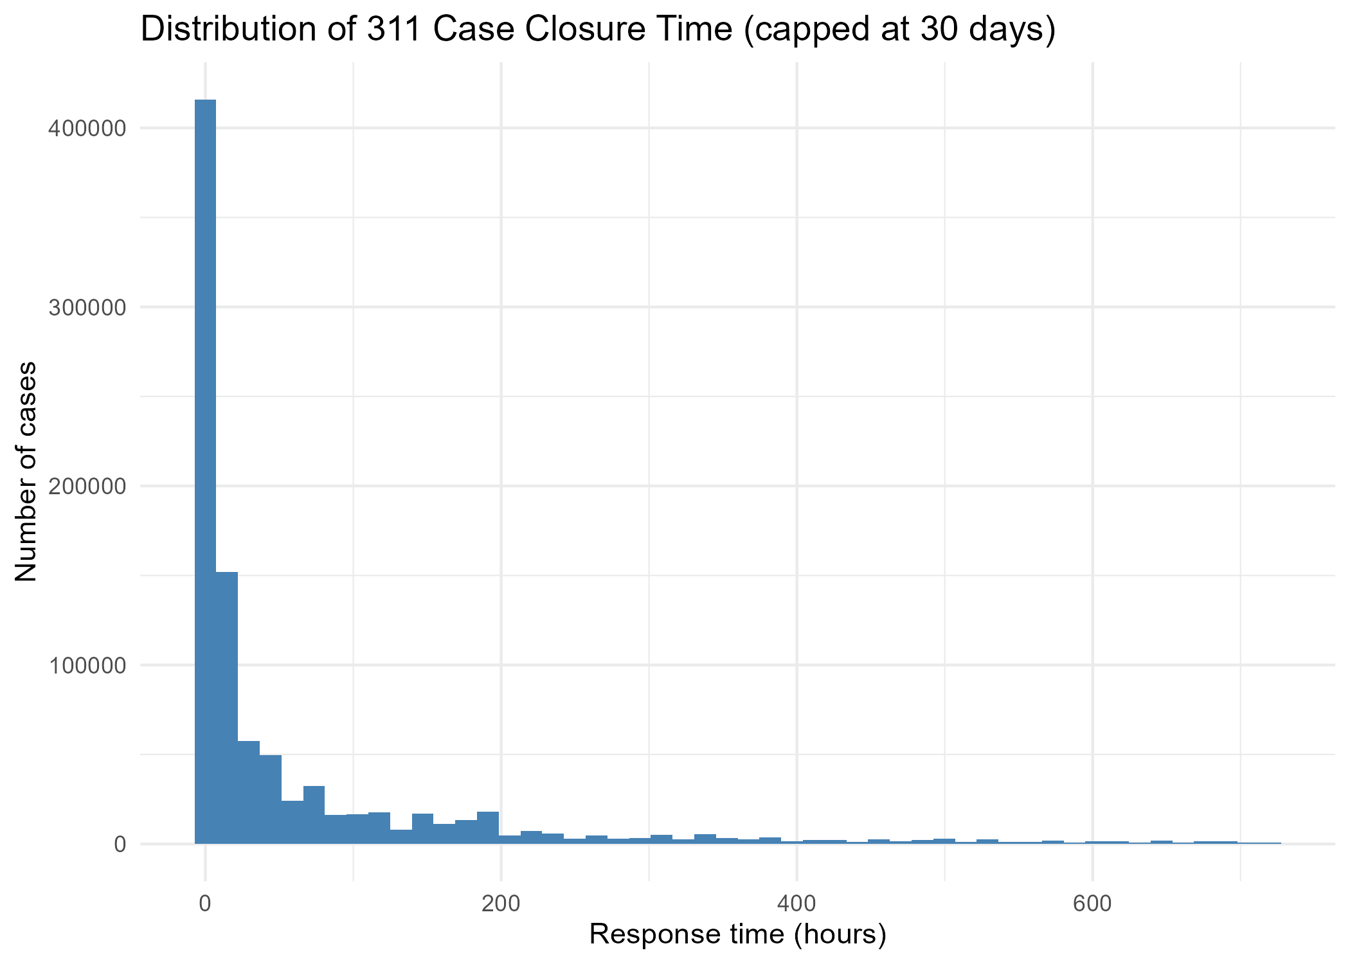
Figure 1. Response time is heavily right-skewed: most cases close within a few days, but a long tail of cases remain open for weeks or months, which is why the mean (293.9 hours) greatly exceeds the median (17.5 hours, not shown in chart).

Chart 2. Average Response Time by Neighborhood Income Tier and Year
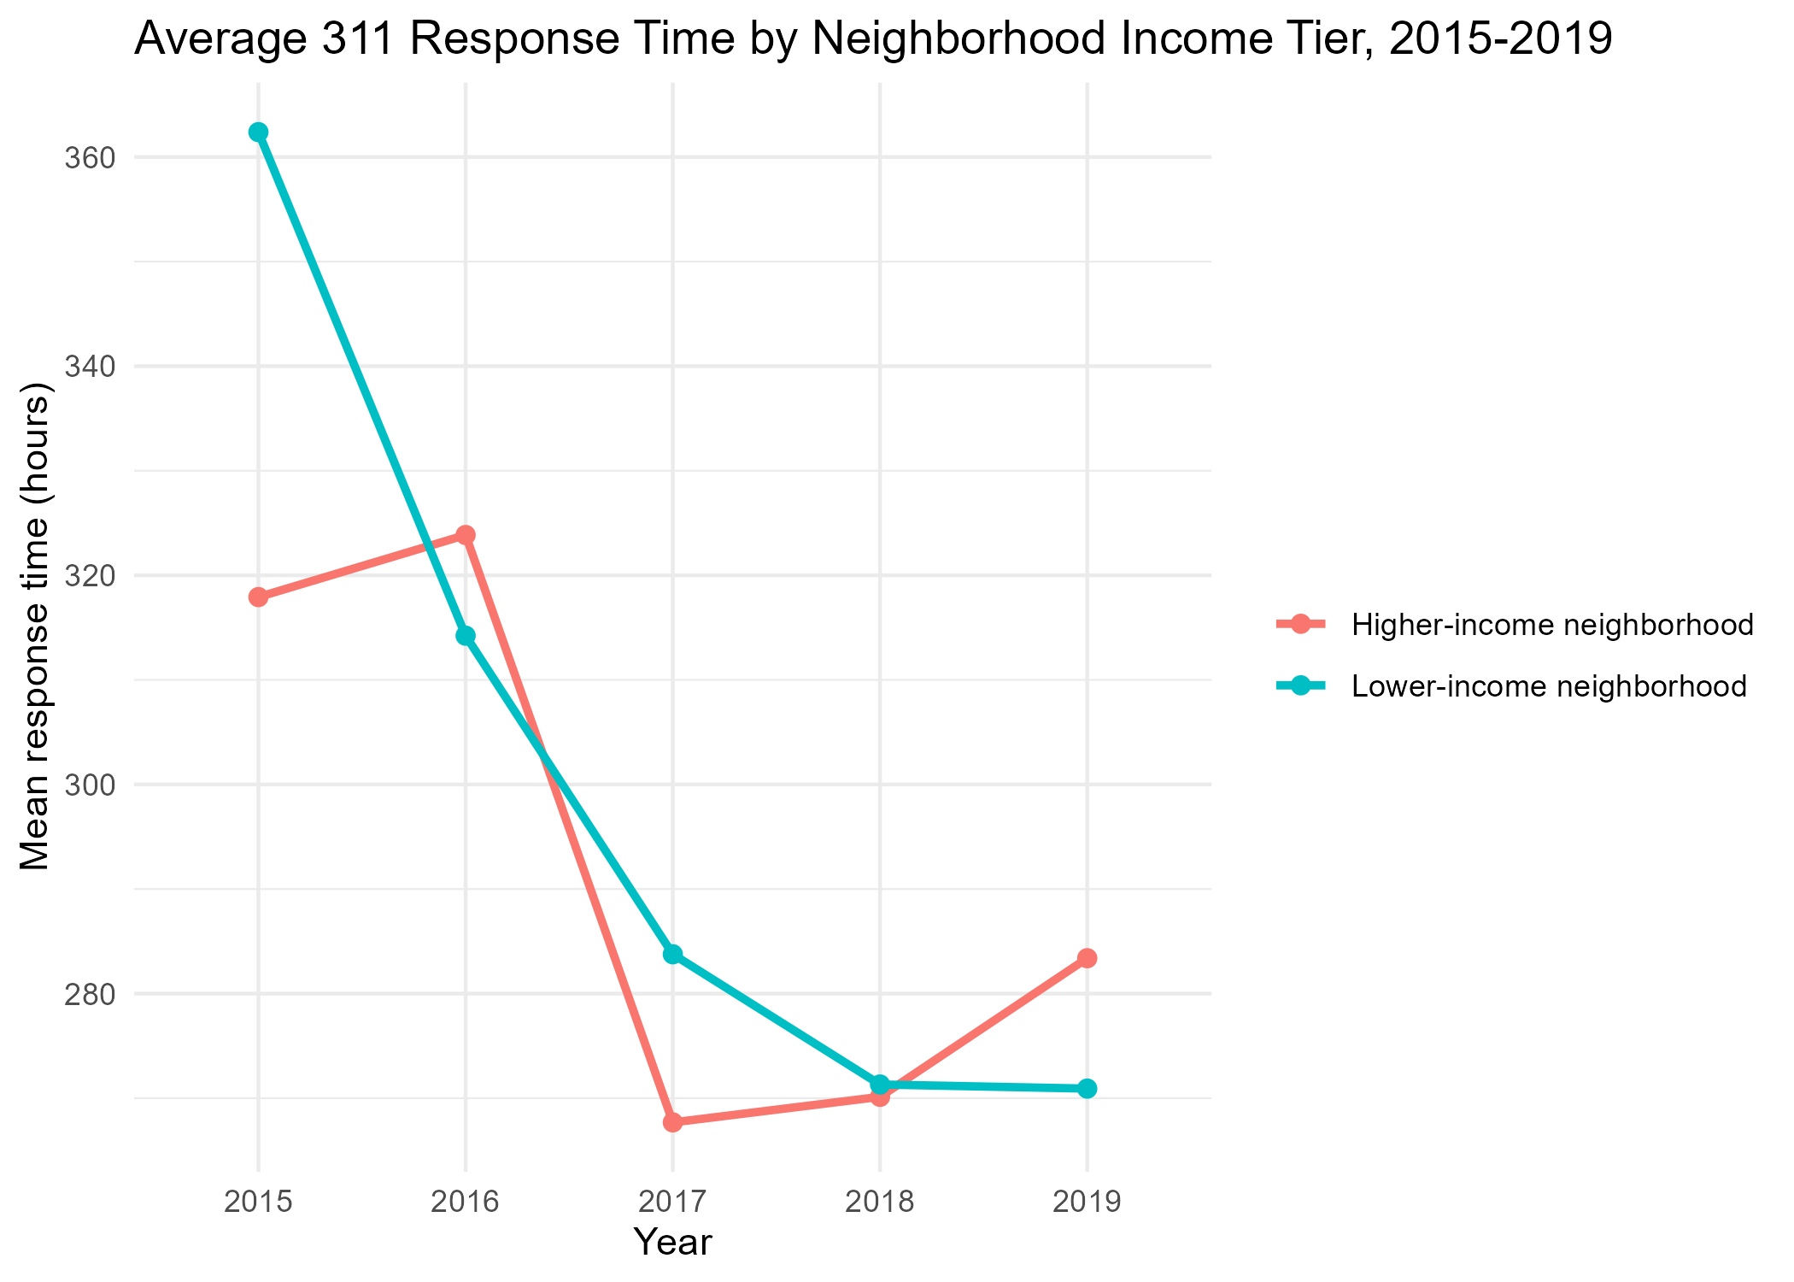
Figure 2. Both neighborhood income tiers show substantial improvement in average response time from 2015 to 2019. Lower-income neighborhoods (teal) started 2015 with a markedly higher average response time than higher-income neighborhoods, and while the two tiers converged by 2017-2018, higher-income neighborhoods show a modest uptick in 2019 while lower-income neighborhoods continued to improve slightly.

Analytical Plan and Methods
Two regression-based methods were used to test whether neighborhood socioeconomic characteristics predict 311 responsiveness after controlling for operational factors (department, channel, year, season). Correlation and ANOVA were not used as primary methods, per the assignment requirements.

Method 1: Multiple Linear Regression (Outcome: response_hours)
A multiple linear regression was fit with response time (hours) as the outcome and department group, submission channel, year, season, neighborhood median household income, poverty rate, and percent minority as predictors. Reference categories: Department = Inspectional Services; Channel = Mobile App; Year = 2015; Season = Fall.
Term | Estimate (hrs) | SE | t | p-value
Intercept | 679.866 | 14.5235 | 46.81 | < .001
Dept: Mayor's 24-Hour Hotline | -301.467 | 6.2689 | -48.09 | < .001
Dept: Other City Services | 358.943 | 7.1347 | 50.31 | < .001
Dept: Parks & Recreation | 459.018 | 5.2187 | 87.96 | < .001
Dept: Public Works / Water & Sewer | -598.372 | 3.6369 | -164.53 | < .001
Dept: Transportation | -572.698 | 4.0280 | -142.18 | < .001
Channel: Other / Internal | 402.426 | 4.2736 | 94.17 | < .001
Channel: Phone | 60.534 | 2.0557 | 29.45 | < .001
Channel: Web / Self-Service | 78.434 | 4.0776 | 19.24 | < .001
Year: 2016 | -27.796 | 3.0057 | -9.25 | < .001
Year: 2017 | -43.954 | 2.9092 | -15.11 | < .001
Year: 2018 | -29.938 | 2.8997 | -10.32 | < .001
Year: 2019 | -16.355 | 2.9284 | -5.58 | < .001
Season: Spring | -5.217 | 2.5440 | -2.05 | .040
Season: Summer | -26.485 | 2.5145 | -10.53 | < .001
Season: Winter | 25.068 | 2.5657 | 9.77 | < .001
Median household income ($) | 0.000 | 0.0001 | 4.97 | < .001
Poverty rate (proportion) | 107.930 | 20.9702 | 5.15 | < .001
Percent minority (proportion) | 3.258 | 8.0518 | 0.40 | .686
Table 3. Linear regression results predicting response time in hours (N = 1,031,658). Model fit: R² = .109, Adjusted R² = .109, F(18, 1,031,639) = 7,016, p < .001.
The model is highly statistically significant overall (p < .001) but explains a modest 10.9% of the variance in response time, indicating that the specific type of complaint, staffing levels, and other factors not captured here account for most of the variation. Department and channel are the strongest predictors: Public Works/Water and Transportation cases close roughly 570-600 hours faster than Inspectional Services cases, while Parks & Recreation and Other City Services cases take 360-460 hours longer, holding other factors constant. All five years are significantly faster than 2015 (reductions of 16-44 hours), though the improvement was smaller in 2019 than in 2017, suggesting a partial plateau or slight regression in recent-year performance. Winter cases take about 25 hours longer than fall cases, consistent with snow- and storm-related workload. Turning to the equity predictors, poverty rate is a significant positive predictor (b = 107.9, p < .001): moving from a 0% to 100% poverty rate is associated with roughly 108 additional hours to close a case, all else equal. Median household income is also significantly positive (b = 0.00047, p < .001), meaning wealthier neighborhoods show slightly longer response times net of department and channel mix -- the opposite direction from the poverty-rate finding. This apparent tension is discussed further below. Percent minority was not a significant predictor once poverty rate and income were included (p = .686).

Method 2: Logistic Regression (Outcome: overdue)
A binary logistic regression was fit with case overdue status (1 = overdue) as the outcome, using the same predictor set. Coefficients are reported as odds ratios (OR) with 95% Wald confidence intervals for interpretability. Reference categories are the same as above.
Term | Odds Ratio | 95% CI Lower | 95% CI Upper
Intercept | 0.3255 | 0.2965 | 0.3574
Dept: Mayor's 24-Hour Hotline | 0.0053 | 0.0043 | 0.0066
Dept: Other City Services | 0.4658 | 0.4481 | 0.4842
Dept: Parks & Recreation | 0.1908 | 0.1841 | 0.1977
Dept: Public Works / Water & Sewer | 0.2717 | 0.2668 | 0.2767
Dept: Transportation | 0.2682 | 0.2625 | 0.2741
Channel: Other / Internal | 0.5981 | 0.5781 | 0.6188
Channel: Phone | 1.1567 | 1.1414 | 1.1723
Channel: Web / Self-Service | 0.7548 | 0.7343 | 0.7759
Year: 2016 | 0.3424 | 0.3361 | 0.3489
Year: 2017 | 0.3659 | 0.3595 | 0.3724
Year: 2018 | 0.4277 | 0.4205 | 0.4351
Year: 2019 | 0.4411 | 0.4335 | 0.4488
Season: Spring | 1.3588 | 1.3355 | 1.3826
Season: Summer | 1.0663 | 1.0475 | 1.0854
Season: Winter | 1.9741 | 1.9417 | 2.0071
Median household income ($) | 1.0000 | 1.0000 | 1.0000
Poverty rate (proportion) | 4.9335 | 4.3023 | 5.6572
Percent minority (proportion) | 1.4336 | 1.3610 | 1.5100
Table 4. Logistic regression results predicting case overdue status (N = 1,031,500). Model fit: Null deviance = 846,489 on 1,031,499 df; Residual deviance = 778,107 on 1,031,481 df; AIC = 778,145.
The equity story is clearer in the logistic model. Poverty rate has the largest effect of any predictor (OR = 4.93, 95% CI [4.30, 5.66]): a neighborhood at 100% poverty has roughly 4.9 times the odds of an overdue case compared to a neighborhood at 0% poverty, holding department, channel, year, and season constant; equivalently, each 10-percentage-point increase in poverty rate is associated with about a 17% increase in the odds of a case being overdue. Percent minority is independently significant (OR = 1.43, 95% CI [1.36, 1.51]): each 10-percentage-point increase in a neighborhood's minority population share is associated with roughly a 4% increase in the odds of an overdue case, net of poverty and income. Median household income shows a small but significant positive association (OR = 1.000006 per dollar, equivalent to roughly a 6% increase in odds per $10,000 of additional income), again running counter to the poverty-rate direction. Consistent with the linear model, all years from 2016-2019 show substantially lower odds of an overdue case than 2015 (ORs of 0.34-0.44), and winter cases have nearly double the odds of being overdue relative to fall (OR = 1.97). Department remains the dominant operational predictor: Mayor's Hotline cases are rarely overdue (OR = 0.005 relative to Inspectional Services), while Inspectional Services itself has the highest overdue rate of any department group in the model.

Reconciling the Income and Poverty Findings
Poverty rate and median household income point in opposite directions in both models: higher poverty is associated with slower, more often overdue service, while higher median income is (weakly) associated with slightly slower service as well. A plausible explanation is that these two variables are not simply opposite ends of the same scale at the case level -- wealthier neighborhoods may generate a different mix of complaint types (e.g., a higher share of lower-urgency requests such as parking or noise complaints that are not prioritized the same way as public-safety or public-works issues), while poverty rate captures a more direct measure of neighborhood need and, potentially, under-resourcing. This distinction, along with the specific complaint-type mix by neighborhood, is a natural next step for the final project.

Limitations
- Response time is right-censored for cases still open at the time of data extraction; these were excluded from the response-time model, which may understate delays for the slowest-moving, unresolved cases.
- The neighborhood crosswalk required population-weighted averaging for combined 311 labels (e.g., "Allston / Brighton"), which introduces some imprecision relative to case-level geocoding.
- Census/BPDA neighborhood characteristics are a single five-year (2015-2019) snapshot and do not vary by year, so they cannot explain within-neighborhood change over time.
- The R² of the linear model (10.9%) indicates that most variation in response time is driven by factors not modeled here (e.g., specific complaint type, crew availability), which the final project could incorporate using the more granular case_title/reason fields.

References
City of Boston. (2024). 311 Service Requests [Data set]. Analyze Boston. https://data.boston.gov/dataset/311-service-requests
Boston Planning & Development Agency, Research Division. (2021). 2015-2019 neighborhood demographic tables [Data set]. U.S. Census Bureau, American Community Survey. https://www.bostonplans.org/research/research-publications

Appendix: R Code
The complete, commented R script (311_analysis.R) used to bind the five years of 311 data, construct the neighborhood crosswalk, extract and merge the BPDA Census profile, engineer all variables, produce Tables 1-2 and Charts 1-2, and fit the linear and logistic regression models is submitted as a separate file alongside this report.

